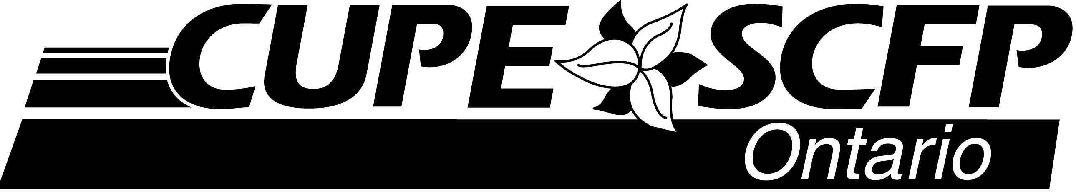

FOR IMMEDIATE RELEASE November 21, 2016
80 Commerce Valley Drive East, Suite 1
Markham, ON L3T 0B2
Phone: 905-739-9739 • Fax: 905-739-9740
Web: cupe.on.ca E-mail: info@cupe.on.ca

CUPE stands with parents from across Ontario to protect community schools

TORONTO, ON – Local community schools are becoming yet another casualty of the broken funding formula that does not factor in the true cost of providing the quality education our children need, said CUPE Ontario President Fred Hahn, speaking at a Queen’s Park rally, organized by the Ontario Alliance Against School Closures.

“High quality public education is at the core of building and maintaining a fair society that doesn’t leave people behind,” said Hahn, speaking to hundreds of parents from across the province. “Local community schools are a necessary part of a good education.”

Today’s rally was organized by parents from all across Ontario, who have come together in response to a rash of planned school closures in rural and smaller towns. The group points out that in parts of norther Ontario some children are already spending up to four hours a day on buses to and from school.

“The current funding formula is broken,” said Terri Preston, Chair of CUPE’s Ontario School Board Coordinating Committee. “The flawed formula is resulting in ongoing cuts to vital support staff and short-sighted school closures. As a result, all across the province the quality of our children’s education is in continual decline.”

“We have a government that continues to prioritize unrealistically low corporate taxes that comes at the expense of the public services we all need. It is no coincidence that we have seen a decline in our education system at the same time as we’re experiencing growing inequality in this province,” said Hahn. “We need a government that is focused on the good of the people and not how to further help corporate shareholders.”

“It’s time for our government to recognize the way they fund education is broken and it’s hurting our kids and our communities,” said Preston. “The government must fix the funding formula to properly account for the real needs of our children and that needs to include local community schools.”

“Until the government deals with the fundamental funding problems, we join families across Ontario in calling for a moratorium on school closures,” said Hahn. “Going forward, the government must revamp the process to ensure community voices and concerns are a critical component of any decision making process.”

-30-

For more information, please contact:
Sarah Jordison, CUPE Communications, 416-578-5638, www.cupe.on.ca

SJ:gb
cope491

